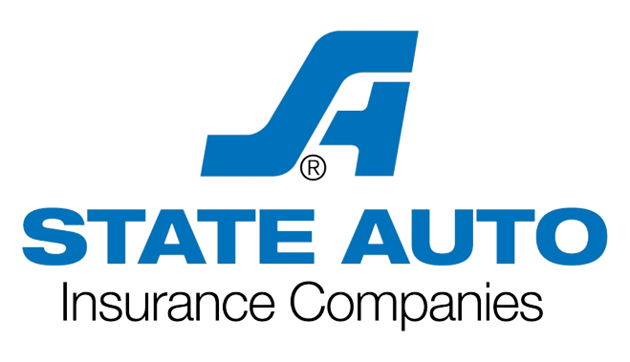 AllState Insurance Company

5100 California Ave STE 108, Bakersfield, CA 93309

Phone: (818) 848-1346

Fax: 424-299-7505

**Identification Cards Personal Auto Policy**

|  |  |
| --- | --- |
| **Policy Number** | **Effective Date Expiration Date Producer Code:** |
| CAP1342659 | 03/12/2023 09/11/2023 **91008** |
| **Insured Name and Address** | **Contact Name and Address - (323) 933-9888** |
| **97 Hillview Ave, Los Altos**  **CA 94022** | **{{name}}**  **ALLSTATE INSURANCE COMPANY**  **5100 California Ave STE 108, Bakersfield, CA 93309** |

 Cut Here



# AllState Insurance Company

# **5100 California Ave STE 108, Bakersfield, CA**

# **93309 Phone: (818) 848-1346**

## CALIFORNIA INSURANCE CARD

Policy Number Effective Date Expiration Date

**CAP1342659 03/12/2023 09/11/2023**

THIS CARD MUST BE CARRIED IN THE INSURED MOTOR VEHICLE AT ALL TIMES AND PRESENTED UPON DEMAND

What to do in the event of an auto accident:

1. Immediately report accidents to the proper authorities.

## Contact: **ALLSTATE INSURANCE COMPANY**

Policyholder(s):

**{{name}}**

**97 Hillview Ave, Los Altos**

**CA 94022**

**Phone:**

## (323)933-9888

1. Obtain names, addresses, phone numbers, and driver’s license Numbers of the people involved in the accident and witnesses.
2. Photographs should be taken of the involved vehicles, including

its damage and license plate numbers at the scene of the accident and emailed to [CAP1342659@claims.insurance.com.](mailto:CAP1342659@claims.mercuryinsurance.com)

## Other Drivers: Excluded Drivers:

Insured Vehicle VIN

**{{viin}}**

## {{car}}

**N.A.I.C. No. 40655**

We will not be responsible for any unreasonable towing or storage fees.

Examine policy exclusions carefully. This form does not constitute any part of your insurance policy.

# AllState Insurance Company

## **5100 California Ave STE 108**

## **Bakersfield, CA** ㅤ **93309** Phone: (818) 848-1346

**CALIFORNIA INSURANCE CARD**

Policy Number Effective Date Expiration Date

**CAP1342659 03/12/2023 09/11/2023**

THIS CARD MUST BE CARRIED IN THE INSURED MOTOR VEHICLE AT ALL TIMES AND PRESENTED UPON DEMAND

What to do in the event of an auto accident:

* 1. Immediately report accidents to the proper authorities.

## Contact: **ALLSTATE INSURANCE COMPANY**

Policyholder(s) :

**{{name}}**

**97 Hillview Ave, Los Altos**

**CA 94022**

**Phone:**

## (323)933-9888

* 1. Obtain names, addresses, phone numbers, and driver’s license Numbers of the people involved in the accident and witnesses.
  2. Photographs should be taken of the involved vehicles, including

its damage and license plate numbers at the scene of the accident and emailed to [CAP1342659@claims.nsurance.com.](mailto:CAP1342659@claims.mercuryinsurance.com)

## Other Drivers: Excluded Drivers:

Insured Vehicle VIN

**{{viin}}**

## {{car}}

**N.A.I.C. No. 40655**

We will not be responsible for any unreasonable towing or storage fees.

Examine policy exclusions carefully. This form does not constitute any part of your insurance policy.